**Assignment-8.2**

**Name: E.Harini ;**

**Enrollnumber:2503A51L40;**

**Batch number: 20;**

**Course:AI assisted coding;**

**Task1:**

1. **Prompt:**

Generate test cases for a function is_prime(n) and then implement the

function.

1. **Code**:

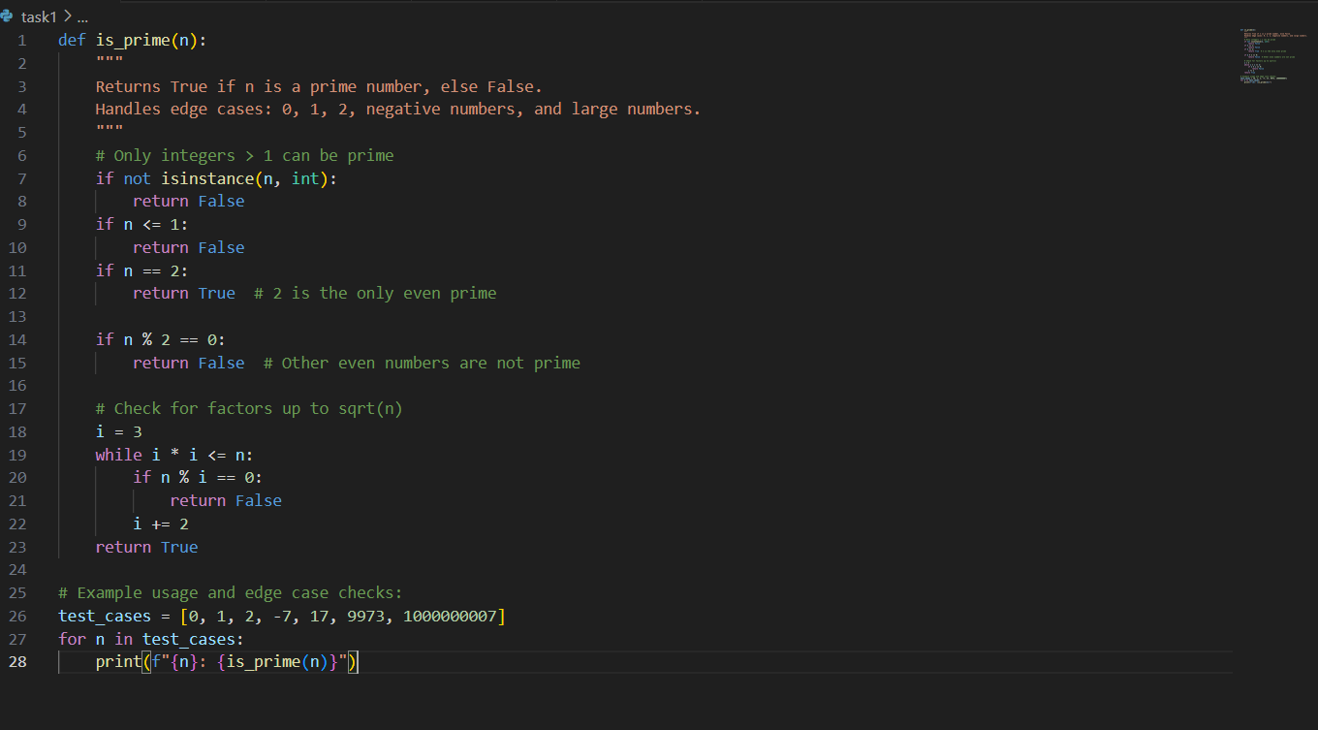

1. **Output:**

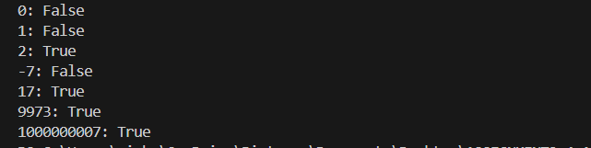

1. **Observation:**

The function correctly checks if a number is prime, handling only integers greater than 1. Returns expected results for edge cases (0, 1, 2, negatives, large primes).

**Task 2:**

1. **Prompt:**

Generate test cases for celsius_to_fahrenheit(c) and fahrenheit_to_celsius(f).

1. **Code:**

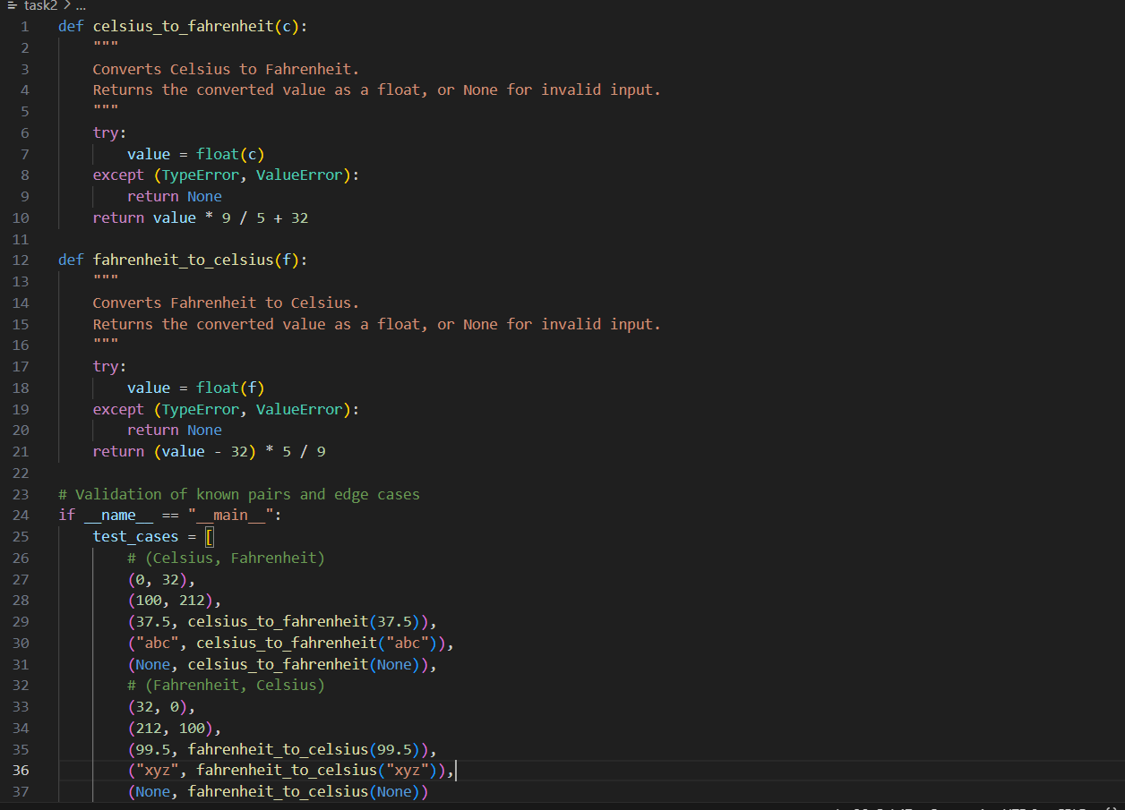

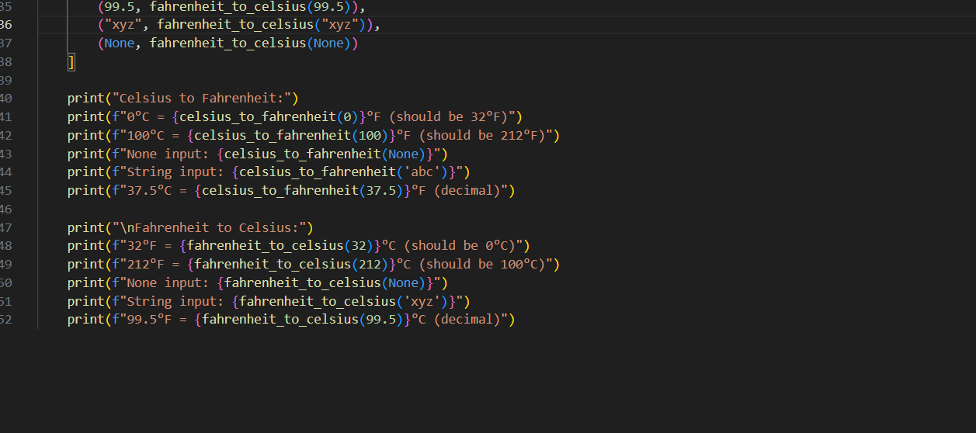

1. **Output:**

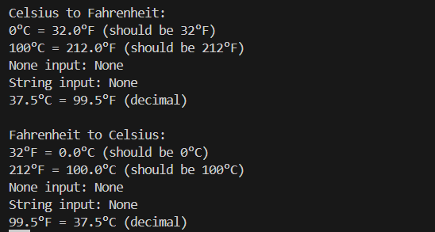

1. **Observation:**

Both functions validate input, returning None for invalid types (e.g., strings, None). Known conversion pairs (0°C = 32°F, 100°C = 212°F) are correct.

**Task3:**

1. **Prompt:**

write test cases for a function count_words(text) that returns the number of  
words in a sentence.

1. **Code:**

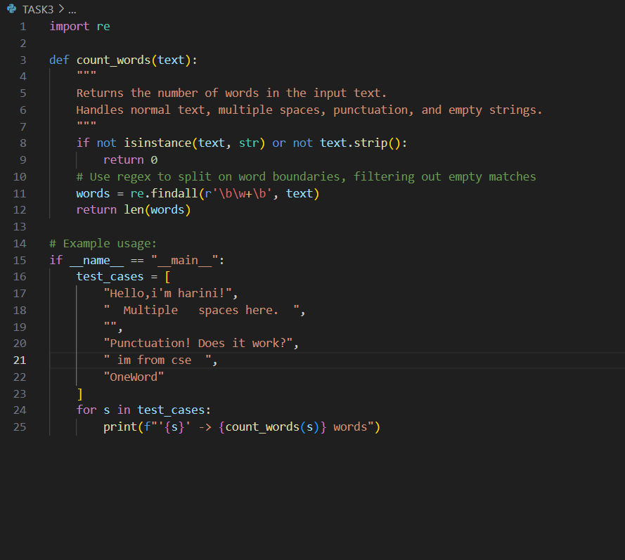

1. **Output:**

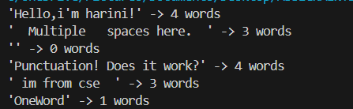

1. **Observation:**

Uses regular expressions to accurately count words, ignoring punctuation. Handles multiple spaces and empty strings, returning 0 when appropriate.

**Task4:**

1. **Prompt:**

Generate test cases for a BankAccount class with Methods:  
deposit(amount)  
withdraw(amount)  
check_balance()

1. **Code:**

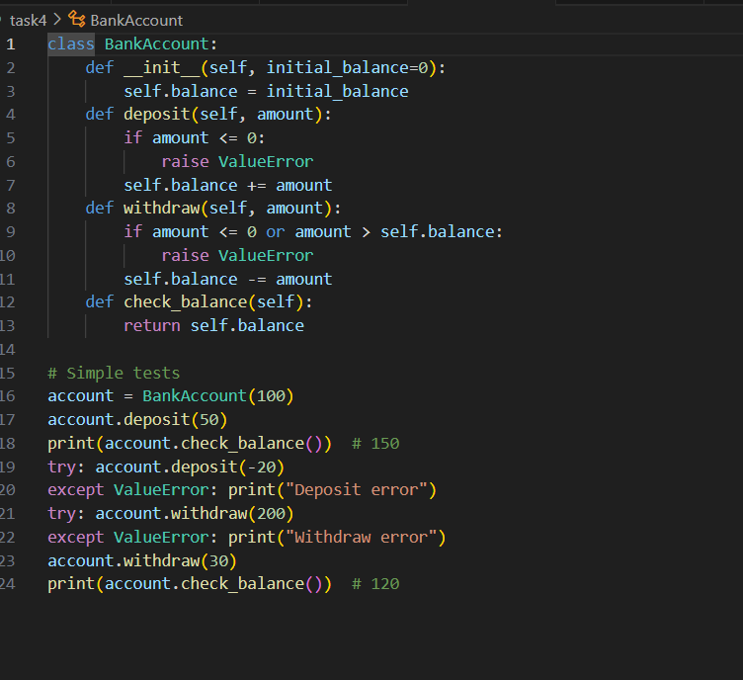

1. **Output:**

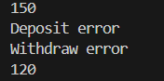

1. **Observation:**

Negative or zero deposits/withdrawals raise errors, protecting against invalid transactions.Tests cover positive, negative, zero, and over-limit transactions.

**Task5:**

1. **Prompt:**

Generate test cases for is_number_palindrome(num), which checks if an integer reads the same backward.  
Examples:  
121 → True  
123 → False  
0, negative numbers → handled gracefully.

1. **Code:**

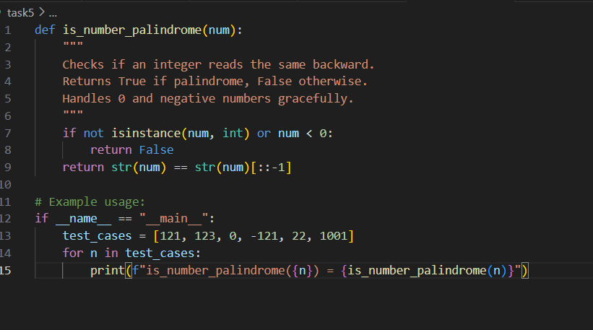

1. **Output:**

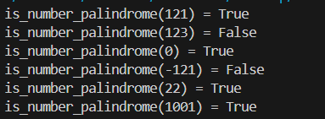

1. **Observation:**

Handles 0 as a palindrome (True), negatives and non-integers gracefully (False).Uses string reversal for simplicity and correctness.